- Download a small dataset of IPL cricket matches (CSV or Excel), load it into a pandas DataFrame, and perform univariate analysis by printing the summary statistics (mean, median, min, max, std) for the 'total_runs' column.
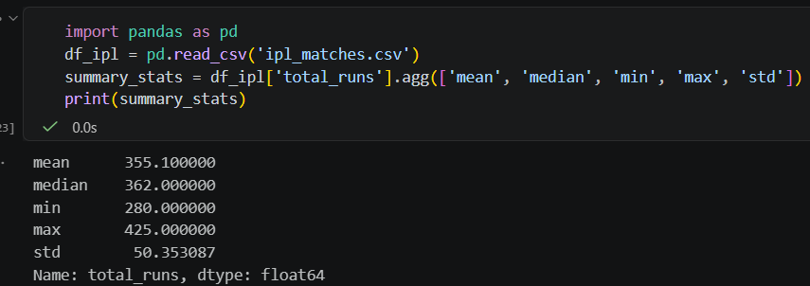

- Using a dataset of Flipkart product reviews (at least columns: 'rating', 'category'), create a bar plot showing the count of reviews for each rating (1-5 stars) using matplotlib or seaborn.
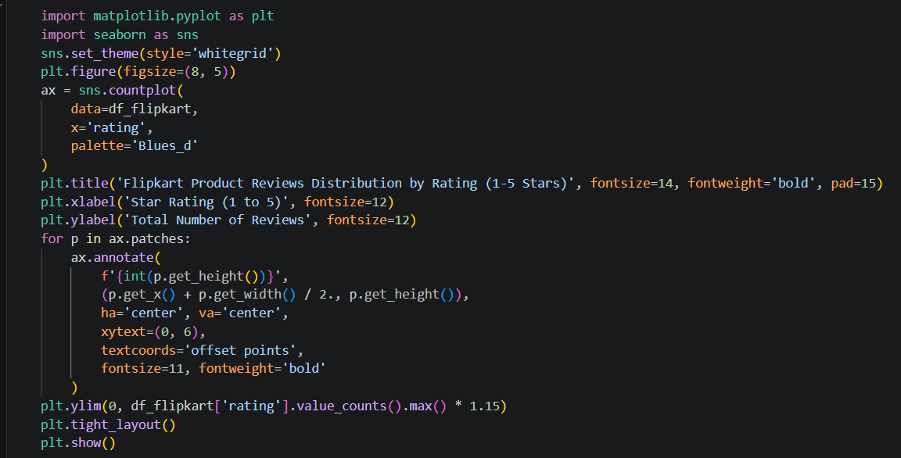
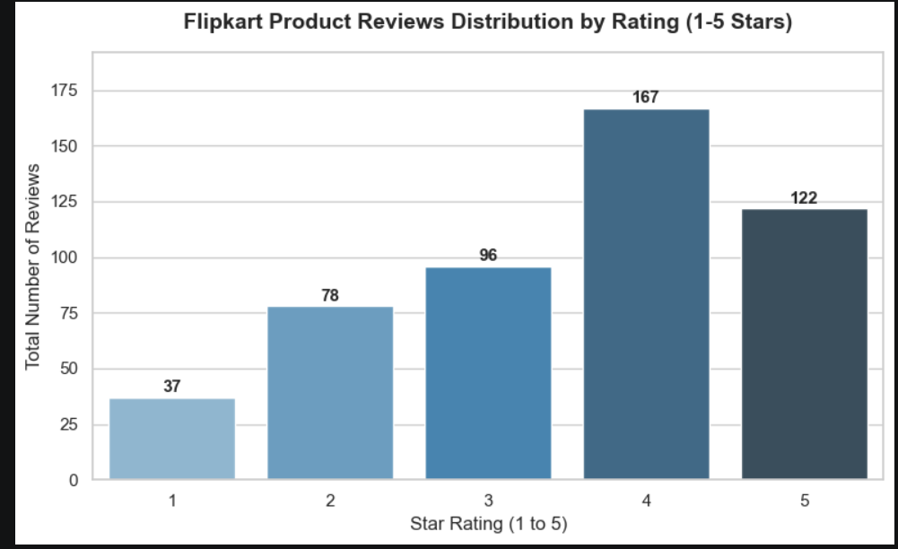
- Take a dataset of Zomato restaurant listings (with 'average_cost_for_two' and 'user_rating' columns) and create a scatterplot to visualize the relationship between cost and user rating. Use seaborn's scatterplot() function and label the axes clearly.
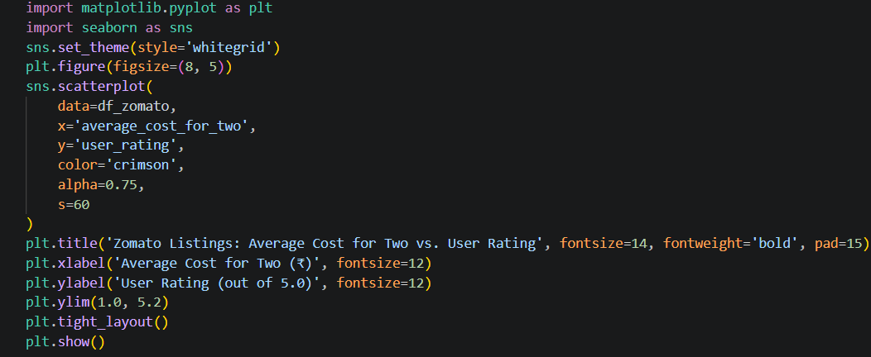
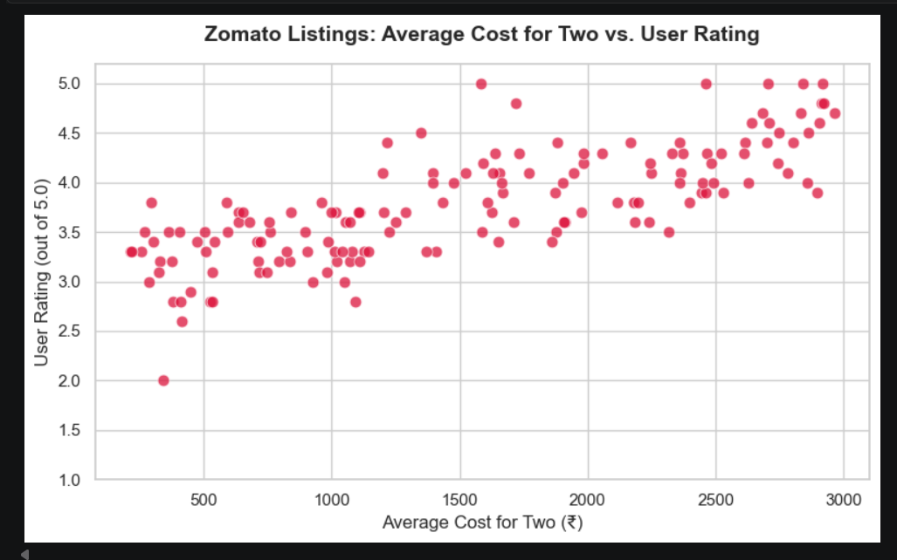

- For a BookMyShow movie dataset (with 'genre' and 'box_office_collection' columns), use groupby analysis to find the average box office collection for each genre and display the results as a sorted table.
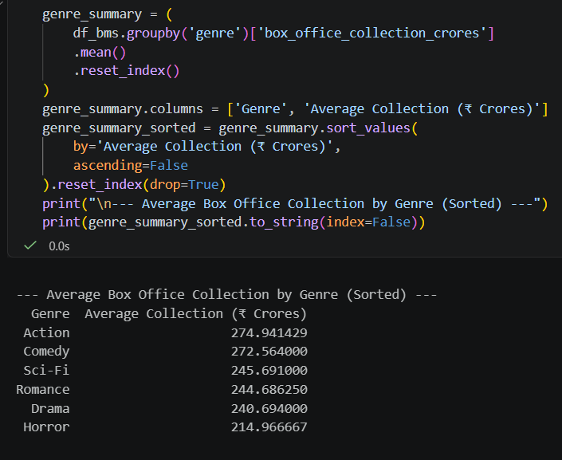

- Use the seaborn 'pairplot' function on a Spotify songs dataset (with at least 'danceability', 'energy', 'valence', and 'popularity' columns) to visualize pairwise relationships between these features. Briefly describe one interesting pattern you observe.
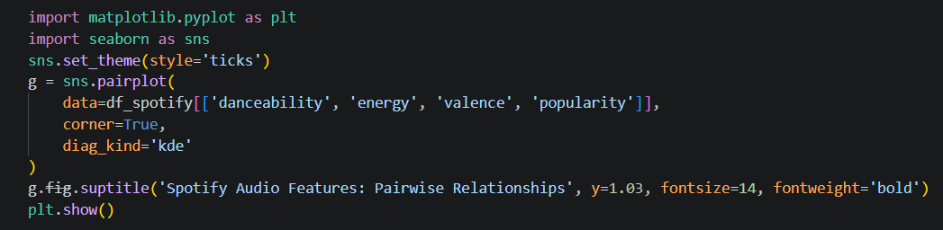

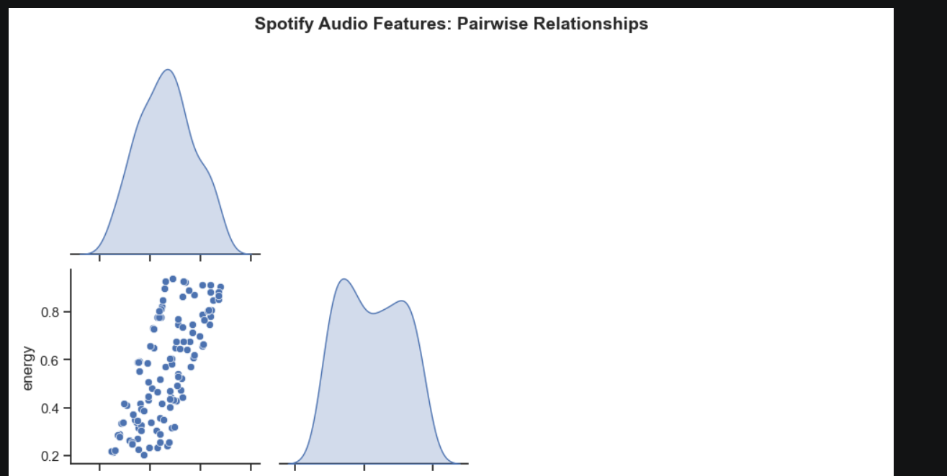
S